**Fire4s   
Gauteng Public Transport Cost & Time Dashboard**

1.Project Overview  
  
The Gauteng Public Transport Dashboard is a browser-based interactive web app that visualizes and compares different public transportation options across Pretoria and Johannesburg, South Africa, coded with Python, streamlit, pandas, seaborn, matplotlib, which it allows users to:

* Compare transportation options (taxis, Uber, buses, trains, walking)
* Analyse cost per trip, cost per kilometre, monthly cost, and travel time
* View visual comparisons via dynamic bar charts
* Access and explore the raw dataset

2.Tools & Technologies Used

| **Component** | **Description** |
| --- | --- |
| **Python** | Core programming language |
| **Streamlit** | Framework for building the interactive web dashboard |
| **Pandas** | Data analysis and tabular data management |
| **Seaborn** | Advanced visualization and colour palette styling |
| **Matplotlib** | Base library for plotting graphs |

3. App Architecture

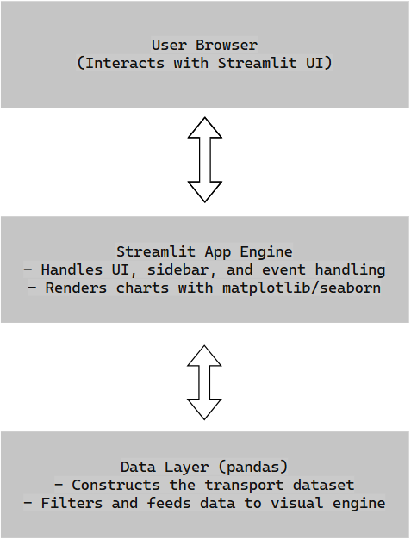

4. Features

**1. Sidebar Selection**

* Users select one of the following metrics:
  + Av Cost per Trip
  + Monthly Cost
  + Cost per km
  + Average Travel Time

**2. Dynamic Visualizations**

* Automatically updates the bar chart based on selection
* Uses meaningful colour palettes for clarity

**3. Data Viewer**

* An expandable section shows the full raw dataset for transparency

**4. Mobile and Desktop Support**

* Streamlit ensures compatibility across devices and screen sizes

5. Installation & Security Features

**Prerequisites**

* Python 3.8 or newer
* pip (Python package installer)

**Install Dependencies:**

bashCopyEditpip install streamlit pandas matplotlib seaborn

**Run the App:**

bashCopyEditstreamlit run gauteng_transport_dashboard.py

The dashboard will open in your default browser at:

arduinoCopyEdithttp://localhost:8501

This web uses only simulated/static data. No user data is collected or stored. No external APIs are called, making it safe for both local and public use.

6.Link to Project  
<https://dashboard-rk9wo6vgbec55kdewbtadj.streamlit.app/#gauteng-public-transport-cost-and-time-dashboard>